**OPERATING**

**SYSTEM**

**LAB – 4b**

**Process Creation**

**Using Ubuntu App**

**Submitted by: ~**

**Ayushi Kumari**

**RA1911003010865.**

1. **Process Creation using C.**

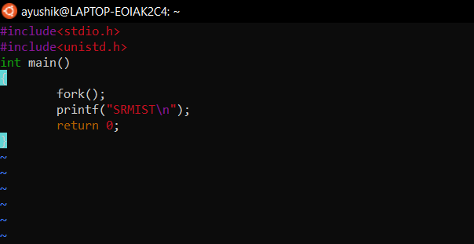

* **OUTPUT: -** SRMIST

SRMIST

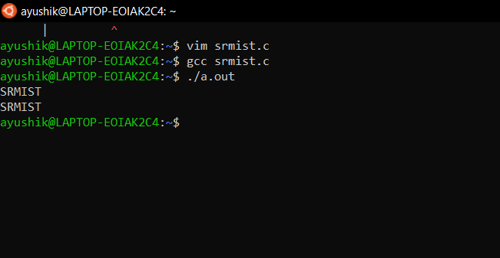

1. **Displaying Process creation using C.**

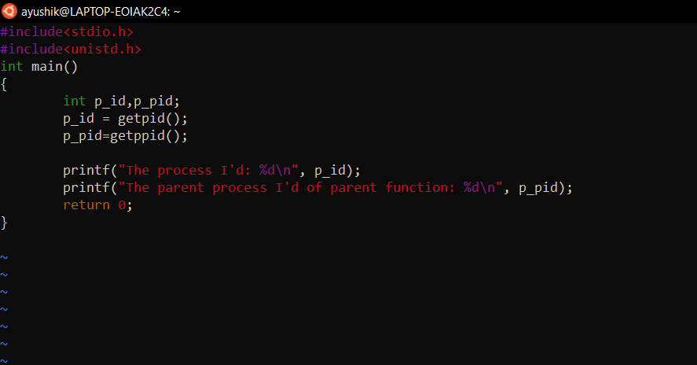

* **OUTPUT: -** The process I’d: 151

The parent process I’d of the parent function: 65

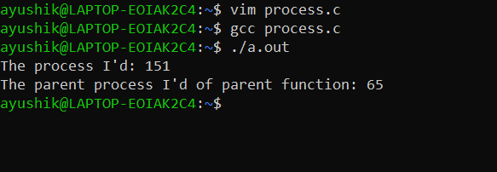

1. **Printing if number is odd or even.**

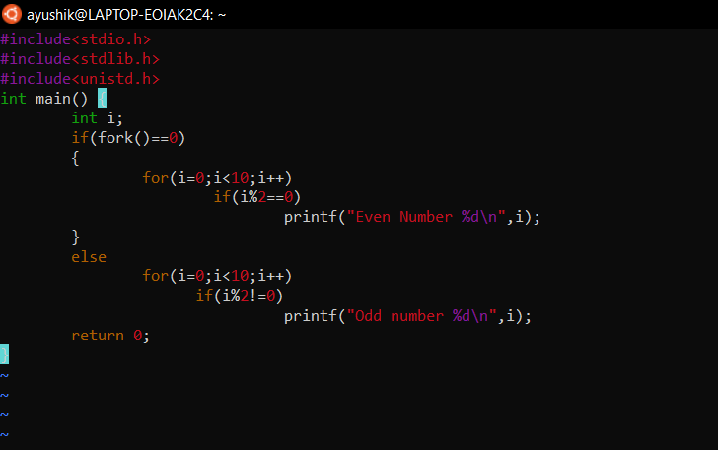

* **OUTPUT: -** Odd number 1

Even number 0

Odd number 3

Even number 2

Odd number 5

Even number 4

Odd number 7

Even number 6

Odd number 9

Even number 8

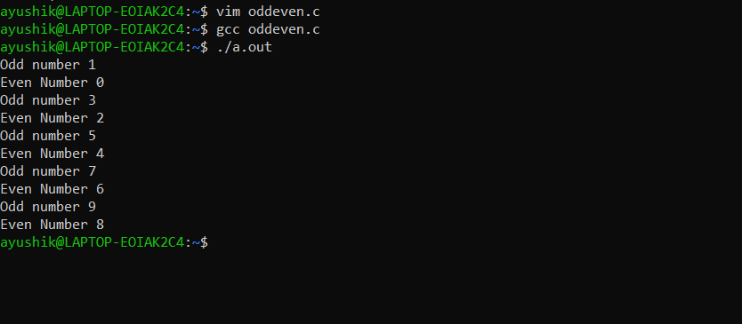

1. **Clone process execution using C.**

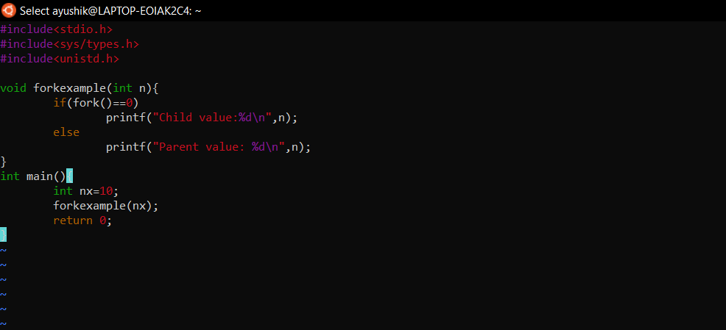

* **OUTPUT: -** Parent value: 10

Child value: 10

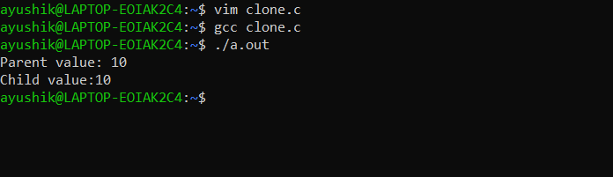

**---------------------------X--------------------------**